Exercise 4:
1. SELECT f_name, l_name
FROM employee_data WHERE salary <= 90000 AND title NOT IN ('Programmer', 'Senior Programmer', 'Multimedia Programmer');
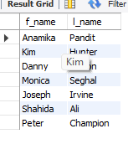
2. 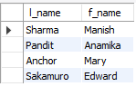
3. SELECT emp_id, f_name, l_name FROM employee_data WHERE age BETWEEN 32 AND 40;
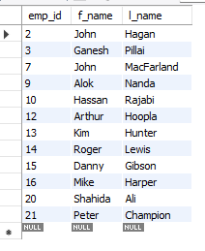
4. 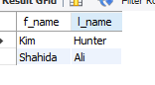 SELECT f_name, l_name
FROM employee_data
WHERE age = 32
AND title NOT LIKE '%programmer%';

